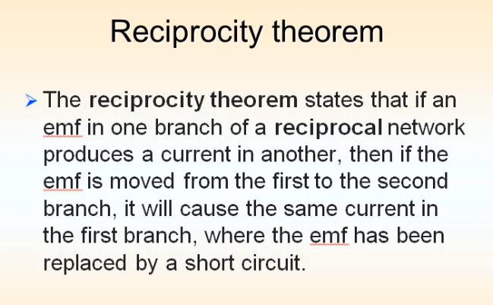

Checking the current across a branch by changing the voltage source position (changing the branch) - by open circuiting a current source and short circuiting a voltage source.

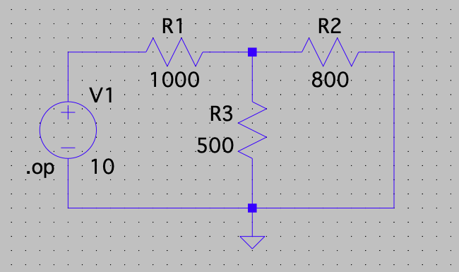

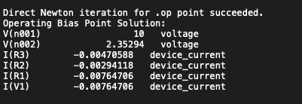

Current through my branch opposite to the voltage source is 0.00294118 which has the direction opposite to the conventional current flow .

NOW AFTER CHANGING,

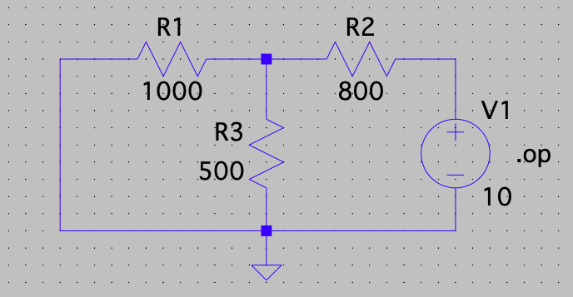

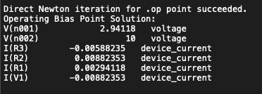

HERE AGAIN THE CURRENT VALUE ACROSS THE OTHER BRANCH OPPOSITE TO THE VOLTAGE SOURCE REMAINS THE SAME THAT IS 0.00294118A